**Automobile Industry in India**

Every other day, we have been hearing about some new launches, some low-cost cars - all customized in a manner such that the common man is not left behind. The CAGR of the Indian automotive industry’s sales between FY 2009 and FY 2020 comes around 8%. The vehicle registrations fell by 29% in the financial year 2020-2021 from 295.8 million registered vehicles to 221.85 million in 2020.

The automobile industry in India was the fifth largest in the world in 2020. Several Indian automobile manufacturers have spread their operations globally as well, asking for more investments in the Indian automobile sector by the MNCs.  
  
Potential of the Automobile industry in 2008, Hyundai Motors alone exported 240,000 cars made in India. Nissan Motors plans to export 250,000 vehicles manufactured in its India plant by 2011. Similar plans are for General Motors.

## Segmentation of market of automobile industry in India:

Passenger Vehicle: 13%  
Commercial Vehicle: 3%  
Three-wheelers: 3%  
Two-wheelers: 81%

#### Indian Automobile Industry SWOT Analysis

Strengths

* The domestic market is large
* The government provides monetary assistance for manufacturing units
* Reduced Labour cost
* Evolving industry
* Continuous product innovation and technological advancement
* Growth shifting to Asian markets
* Increase in demand for luxury commercial vehicles
* Manufacturing facilities in Asian nations to control cost

Weaknesses

* Infrastructural setbacks
* Low productivity
* Too many taxes levied by the government increase the cost of production
* Low investments in Research and Development

Opportunities

* Reduction in Excise duty
* Rural demand is rising
* Income level is at a constant increase
* Introducing fuel-efficient vehicles
* Changing lifestyle and customer demand causing a rise in the sale of two-wheelers and compact cars

Threats

* Increasing rates of interest
* Too much competition
* The rising cost of raw materials
* Steeply rising fuel prices
* Slow economy
* Economic recession

## Automobile industry facts and statistics

1. India was the fifth-largest automobile market in the year 2020.
2. The financial year 2021 statistics:
   1. Passenger vehicles: 27.11 lakhs
   2. Commercial vehicles: 5.69 lakhs
   3. Three-wheelers: 2.16 lakhs
   4. Two-wheelers: 151.79 lakhs

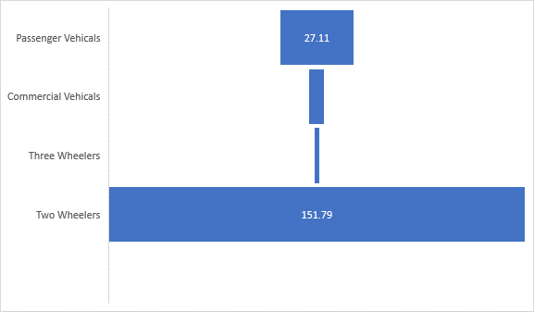

1. Fiat Chrysler invested 250 million dollars in January 2021.
2. Tesla, the electronic car manufacturing company has registered offices in Bangalore and has shown interest in starting a unit in India.
3. In the 2022-2022 union budget the government introduced the voluntary vehicle scrappage policy. This policy will boost India’s demand for new vehicles and remove the old and polluting vehicles off the streets.
4. Delhi government has ordered the construction of 100 battery charging points across the state. This is to promote the sale of electrical vehicles in the capital.